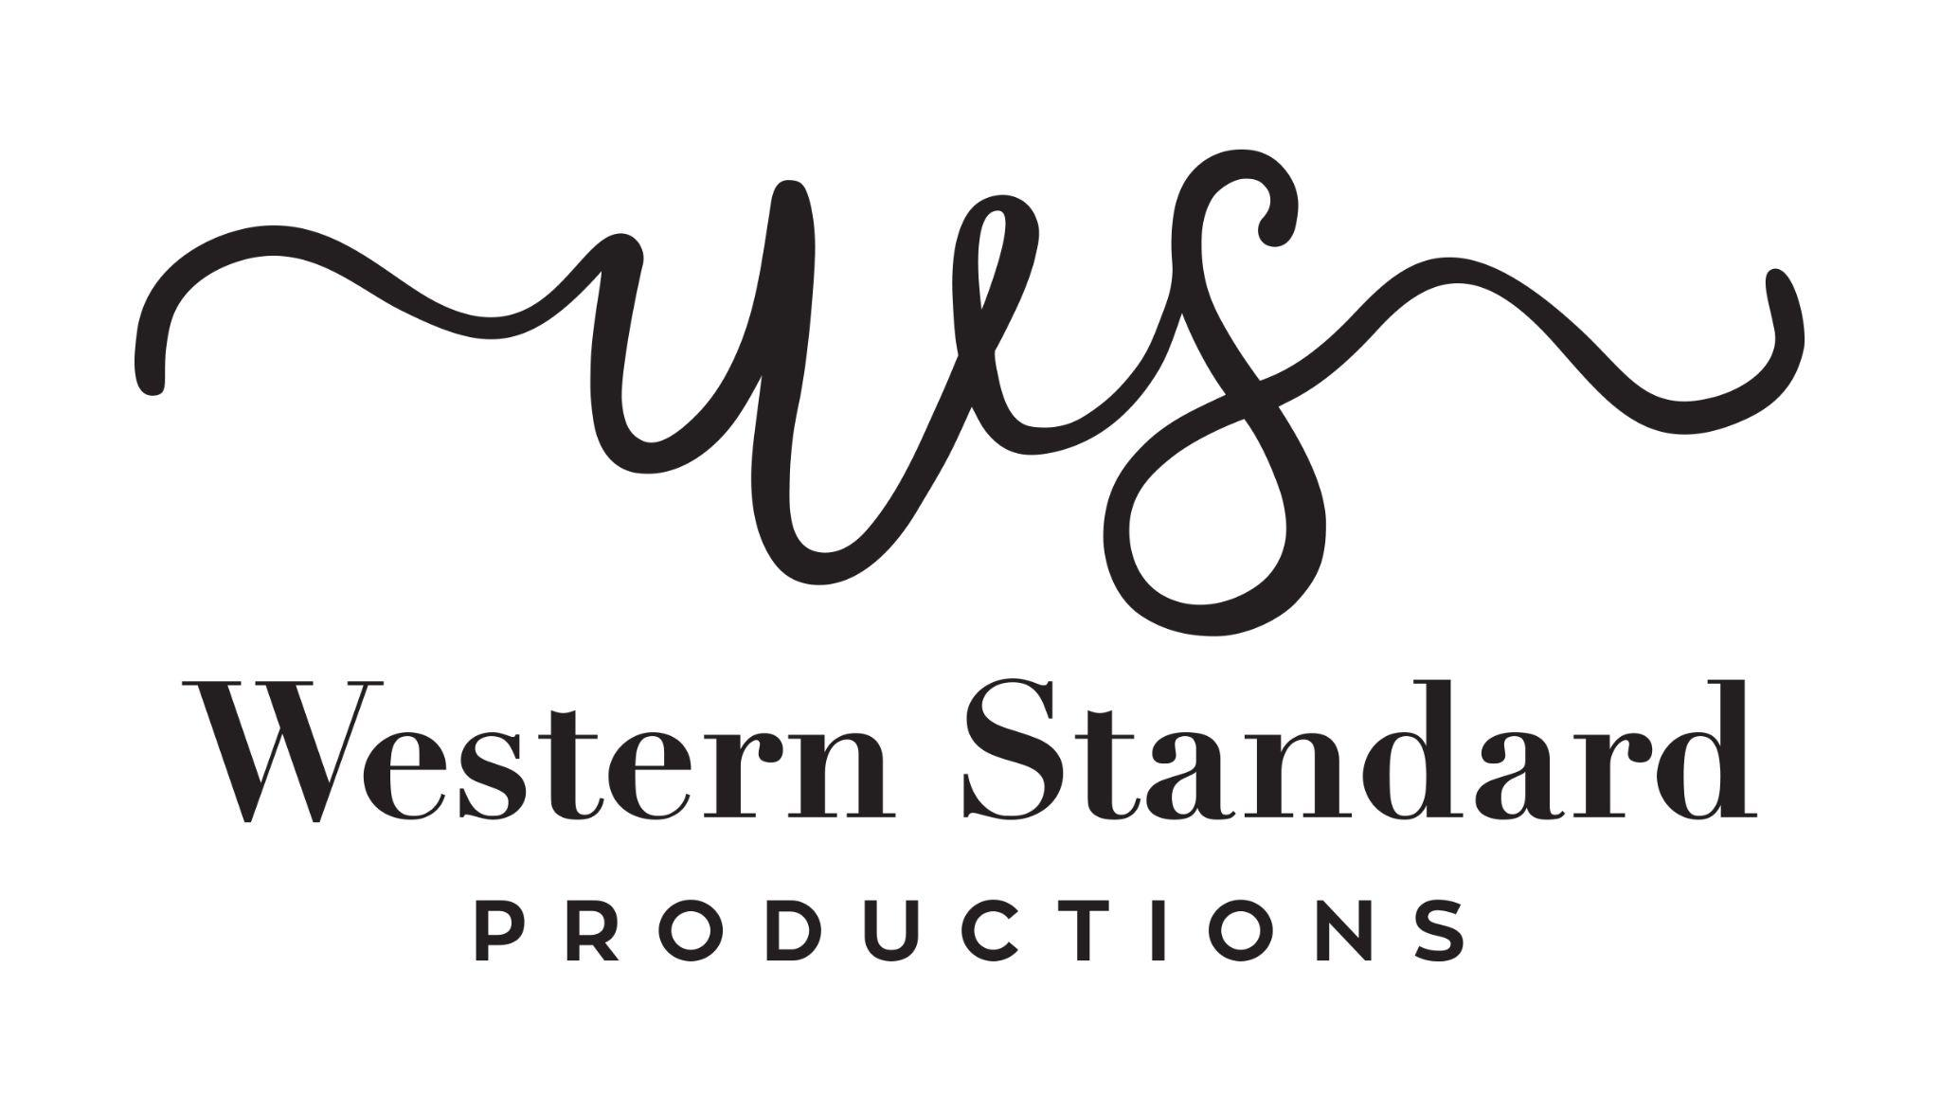
presents

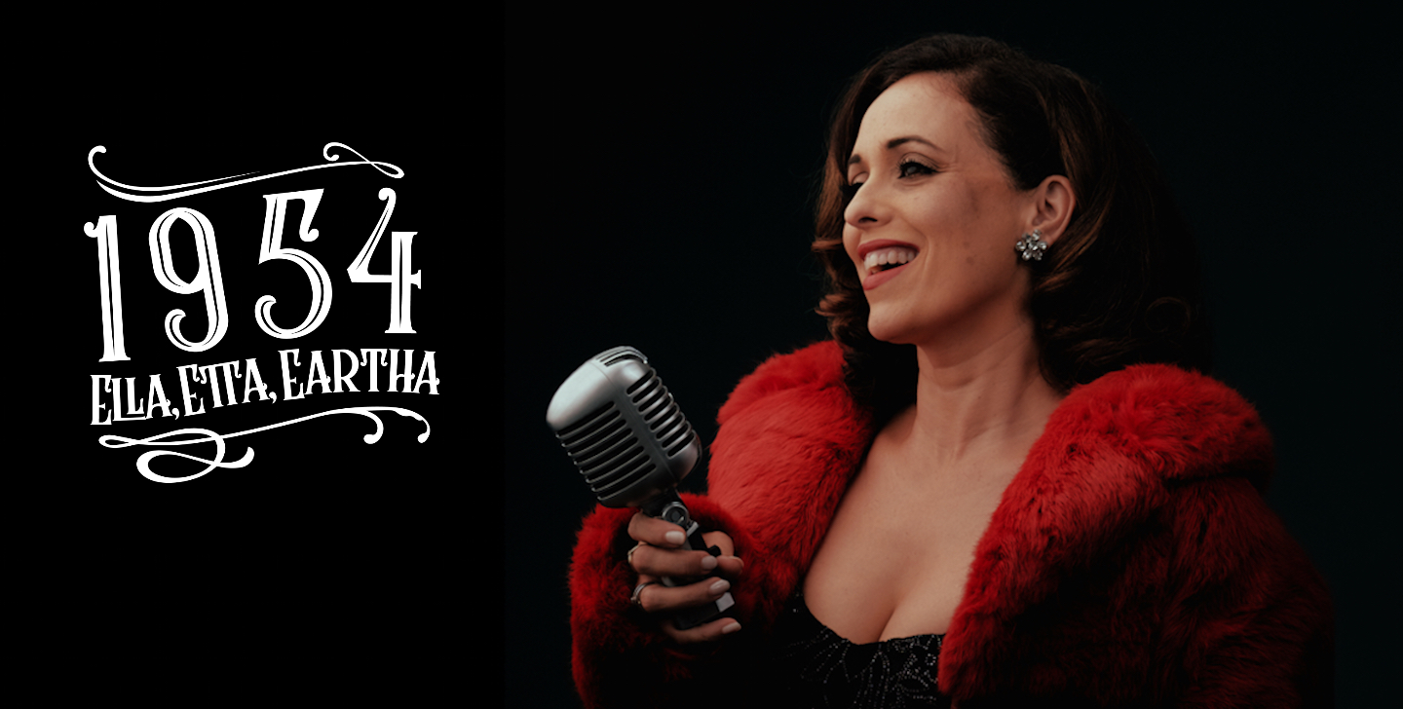

MARKETING KIT

APPROVALS
Please note all marketing materials including print (posters, flyers, press advertising), broadcast (TV and radio ads) and digital (website, emails) require approval before being published or sent to print.

Approvals should be sent to the company contact as listed below. Please allow a 24-hour turn around on all approvals.

COMPANY CONTACT
Melissa Western
admin@westernstandard.com.au
+61 414 267 009

PRODUCTION NAME
1954: Ella, Etta, Eartha

COMPANY NAME
Western Standard Productions

PRESENTATION LINE & BILLING
Western Standard Productions and [your organisation] present

1954: Ella, Etta, Eartha

MARKETING ONE LINER
Swinging jazz, powerful soul & cheeky kitsch featuring Melissa Western

MARKETING COPY

[35 words]

It's 1954. Ella Fitzgerald, Etta James and Eartha Kitt hit the big time with swinging jazz, powerful soul and cheeky kitsch. Melissa Western and her all-female band tell their stories and celebrate their music.

[120 words]

It's the year 1954. Ella Fitzgerald, Etta James and Eartha Kitt are all at the dizzy heights of their careers. With swinging jazz, powerful soul and cheeky kitsch these three women broke new ground for all who followed after. Melissa Western and her world class all-female band pay tribute to this magnificent era in music and inspiring trio of pioneering singers. 50s style abounds.

‘“Western is a force of nature...Great storyteller, feisty, highly enjoyable; ... Warm, witty
and supremely talented ... captivating ...fantastic instrumentalists”
***** ★ ★ ★ ★ ★ Broadway Baby

“Western is absolutely brilliant… Her aptitude for music is vast and versatile” ★ ★ ★ ★ ★ ThreeWeeks magazine [UK]

“Western’s gorgeous singing voice serves her well” The Australian

LEAD MEDIA QUOTE
"warm, witty and supremely talented." ★ ★ ★ ★ ★ Broadway Baby

MEDIA RELEASE
Full media release is available for download:

Download Media Release

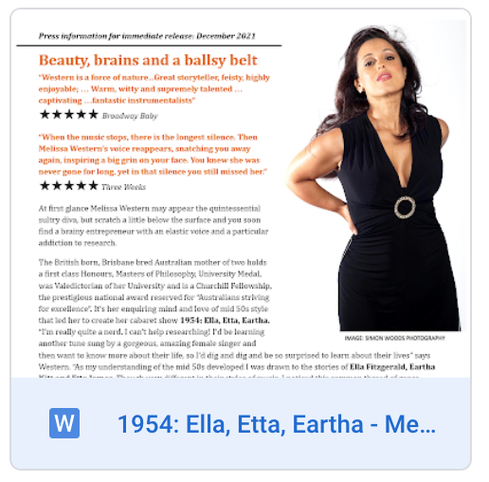

GENRE
- Cabaret
- Jazz
- Live Music

PERFORMANCE DURATION

Show can be run as a 75 minutes straight through or 2 x 40min halves with an interval

AGE SUITABILITY
A perfect fit for audiences 50+
A great event for anyone aged 16+
MANDATORY ACKNOWLEDGMENTS
The following acknowledgement text must be included on all materials (including print, digital and broadcast) created for the tour, but is negotiable for press advertisements where space is limited:

Presented by Western Standard Productions

TBC - tour or venue presenter

LOGO ACKNOWLEDGEMENT

Please include the Western Standard Productions logo where possible.

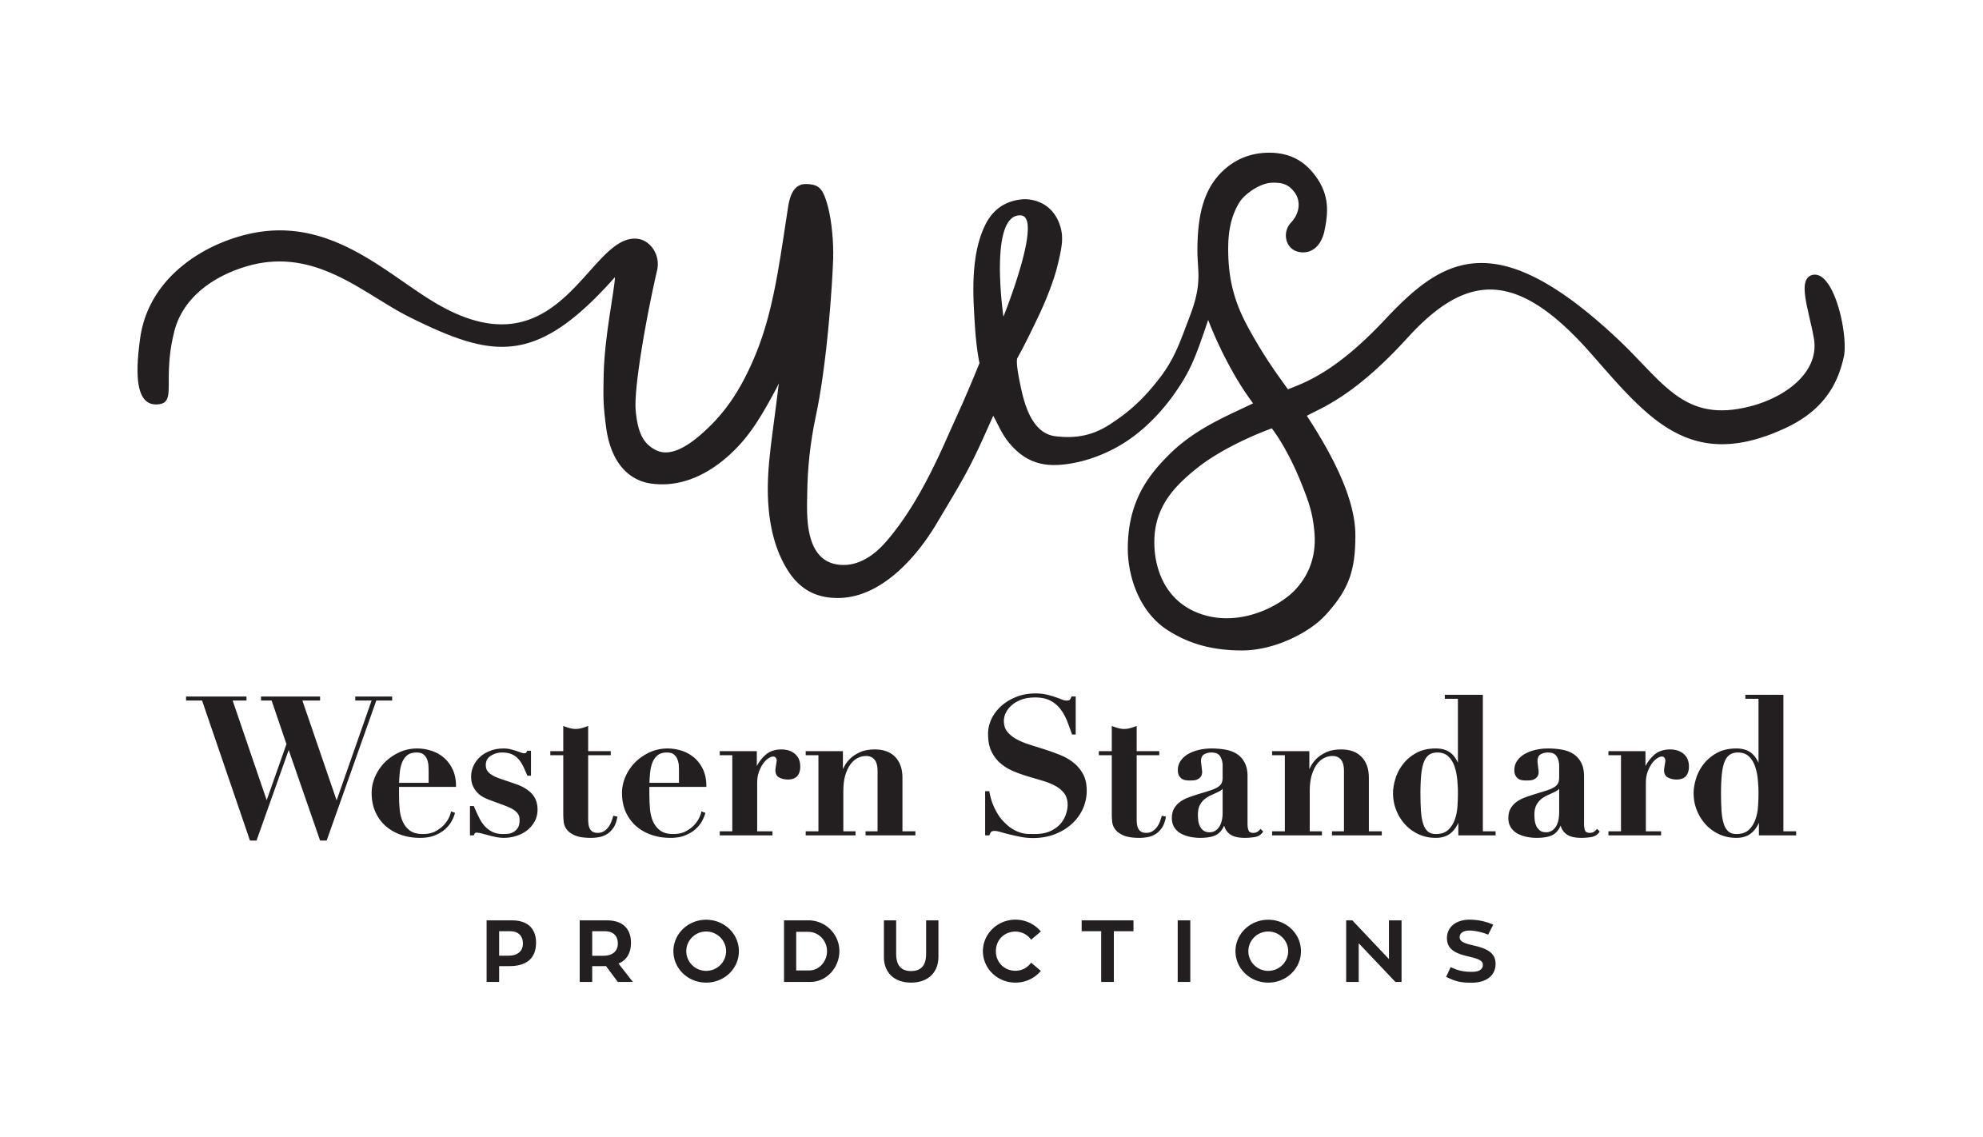

IMAGES
A selection of high res images are available to download

Download images

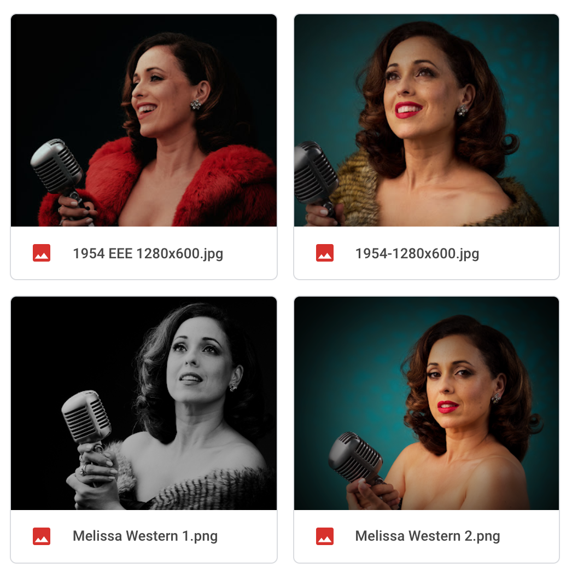

TITLE TREATMENT
Artwork for the show title can be used for your own collateral.



Download title treatment here

KEY ARTWORK
Artwork templates for poster is available to download from Canva.

Venues can edit these to include their performance information, seek approval and print locally.

Canva link to poster here

PRODUCTION & BTS IMAGES
A selection of high res images are available to download

Download images

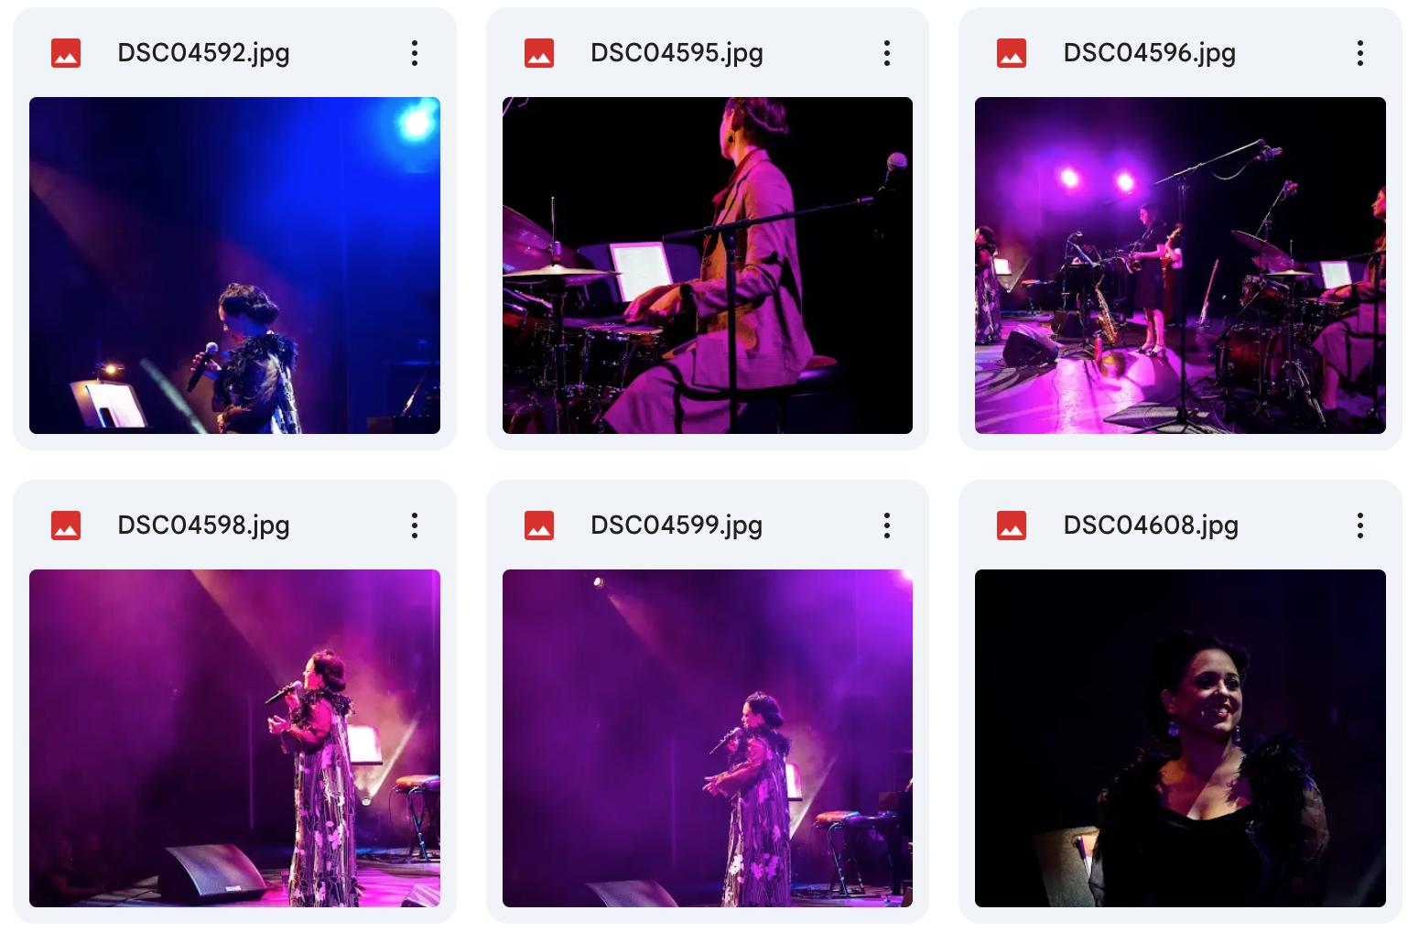

ABOUT THE ARTIST

Melissa Western
British born, Brisbane-raised singer-actor-writer Melissa Western is happily at home in
the worlds of jazz, cabaret and theatre. Over the past fifteen years has performed to
audience and critical acclaim locally in Brisbane, nationally throughout Australia and
internationally in the UK and France. Her self-penned one-woman musical Ella, Marilyn,
Marlene and Me was an official sell-out two consecutive years at the Edinburgh
Festival, garnering five star reviews from ThreeWeeks “absolutely brilliant… enthralling
vocal talents wowed the audience” and four stars from The Scotsman “Melissa Western
is on fire… it’s mainly about the eyes, the face and the voice.” Her original comedy-
cabaret with partner Tnee Dyer, Sweet, Sour and Saucy received critical and audience
acclaim, Western being touted as a “force of nature” (Broadway Baby, 5 stars). The
show went on to be nominated for three Matilda Awards: Best Musical/Cabaret, Best
Female Actor in a Leading Role and Best Set Design as well as Western being named
Favourite Leading Female Performance in the Del Arte Charts, it has since toured
Queensland, Western Australia and the UK.

Melissa is an Edinburgh veteran having toured seven times to the Festival, other career
highlights include performances for the Prime Minister, Queensland Premier, multiple
Women in Voice seasons, Brisbane Festival, Brisbane Powerhouse, Brisbane Cabaret
Festival, Brisbane Jazz Club, Qld Music Festival, Woodford Folk Festival, Valley Jazz
Festival, Brisbane City Hall, Adelaide Fringe Festival, The Tivoli, Bleach Festival, Out of
the Box festival, Gold Coast Jazz and Blues Festival, Gold Coast Arts Centre, L’église –
Avaux (France), Derry Jazz Festival (Ireland), La Boite Theatre, Zen Zen Zo Physical
Theatre.

She has recorded her own original CD Stepping Stone as well as releasing a live jazz
CD, Live &amp; Intimate and featuring on High Tide vol II (Brisbane Jazz Club), Tailspin:
Brisbane Big Band tribute to Paul Gibens and Singin’ and Swingin’ with her Dad, Alan
Western.

Melissa is a Churchill Fellow, was Valedictorian of her graduating Bachelor of Arts at
UQ, holds a University Medal from the University of Queensland, first class Honours
degree and was awarded her Masters of Philosophy in the field of Drama. She was
awarded a prestigious Churchill Fellowship to study improvised musical theatre in the
UK and continues to teach and perform in the ground breaking genre.

WEBSITE
www.melissawestern.com

SHOW WEBSITE
https://westernstandardproductions.com/1954-ella-etta-eartha

SOCIAL LINKS
Facebook: melissawesternartist
Instagram: @melissawesternartist
Youtube: melissawesternartist
Soundcloud: https://soundcloud.com/melissawestern

AWARDS / NOMINATIONS /GRANT RECIPIENT
* Matilda Awards 2022. Winner in two categories. Best Ensemble, Best Musical/Cabaret.
* Matilda Awards 2015. Nominated in three categories: Best Female Actor, Best Musical/Cabaret, Best Set Design.
* Del Arte Charts. Listed as top five favourite: Favourite Leading Female Performance, Favourite Musical/Physical Production.

SUGGESTED TARGET AUDIENCE
1. Morning Melodies segment
2. 30+ lovers of jazz, soul and cabaret
Cross promotions:
There are a few key groups who will respond well to this show. Select merchandise can be sent to offer prizes to these groups in return for promoting the show.

- Jazz and blues appreciation club
- Charity groups like Zonta, Lions and Rotary groups (older couples)
- High end restaurants (couples who dine out)

