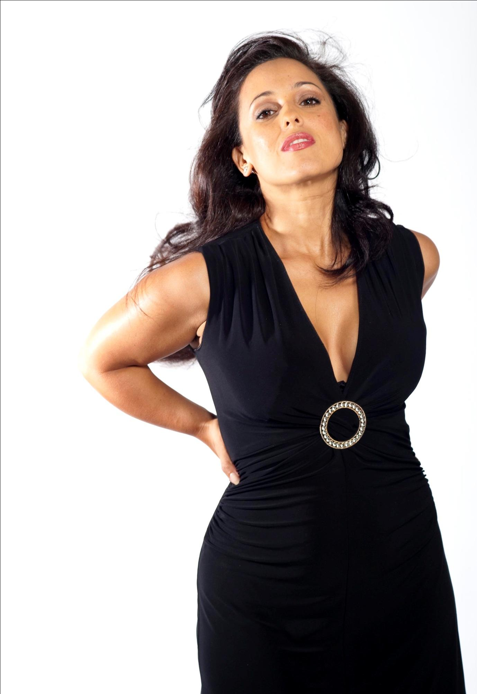
Press information for immediate release: December 2021

Beauty, brains and a ballsy belt
“Western is a force of nature...Great storyteller, feisty, highly enjoyable; … Warm, witty and supremely talented … captivating …fantastic instrumentalists”
★★★★★ Broadway Baby
“When the music stops, there is the longest silence. Then Melissa Western’s voice reappears, snatching you away again, inspiring a big grin on your face. You knew she was never gone for long, yet in that silence you still missed her.”
★★★★★ Three Weeks
At first glance Melissa Western may appear the quintessential sultry diva, but scratch a little below the surface and you soon find a brainy entrepreneur with an elastic voice and a particular addiction to research.
The British born, Brisbane bred Australian mother of two holds a first class Honours, Masters of Philosophy, University Medal, was Valedictorian of her University and is a Churchill Fellowship, the prestigious national award reserved for “Australians striving for excellence”. It’s her enquiring mind and love of mid 50s style that led her to create her cabaret show 1954: Ella, Etta, Eartha. “I’m really quite a nerd. I can’t help researching! I’d be learning another tune sung by a gorgeous, amazing female singer and then want to know more about their life, so I’d dig and dig and be so surprised to learn about their lives” says Western. “As my understanding of the mid 50s developed I was drawn to the stories of Ella Fitzgerald, Eartha Kitt and Etta James. Though very different in their styles of music, I noticed this common thread of genre trailblazing, of three women of colour breaking glass ceilings all around them and paving the way for so many who followed after them”.
IMAGE: SIMON WOODS PHOTOGRAPHY
“I often joke that I was ‘born in the wrong era’ and that the style and music of the 40s and 50s suits my style and personality so much better than the 2020s! But there are also some really interesting social and political narratives that feed into this show. Ella, Etta and Eartha each had to battle against prejudice, poverty and abuse throughout their lives and they had to work so hard to rise above the racism and sexism inherent in the mid century psyche. Of course their music is sublime, but their personal stories of triumph over adversity are just as inspirational”.
It’s these stories that fuel Western’s feast of jazz, soul and cabaret. Joining Melissa onstage is a versatile and talented all-female jazz band featuring some of Brisbane’s very best musicians.
1954: Ella, Etta, Eartha builds on the sellout success of Western’s previous jazz cabaret Oh Lady Be Good. A sellout at the Queensland Cabaret Festival, Anywhere Theatre Festival, Brisbane Jazz Club and Edinburgh Fringe, the show has won over audiences from the prestigious Brisbane City Hall Main Auditorium to the Jumpers & Jazz Festival in Warwick. Having toured around the world to the Speigeltent at the Canterbury Festival, a UK tour (Lincolnshire, Nottinghamshire), Brisbane Jazz Club, Maleny Arts Council, Gold Coast Jazz and Blues Festival and more Melissa and her top notch jazz team are over the moon to be presenting a brand new cabaret in 2022.
INTERVIEW, IMAGES, MORE INFO ENQUIRIES
admin@westernstandard.com.au | 0414 267 009

