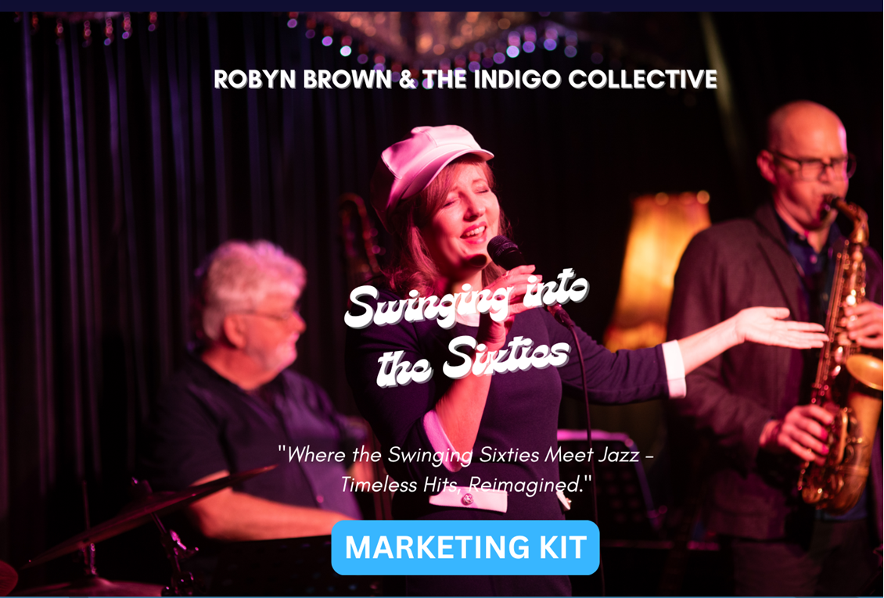

# Robyn Brown & The Indigo Collective

# Swinging into the Sixties

|  |
| --- |
| Please note all marketing materials including print (posters, flyers, press advertising), broadcast (TV and radio ads) and digital (website, emails) require approval before being published or sent to print.  Approvals should be sent to the marketing contact as listed below. Please allow a 24-hour turn around on all approvals. |

|  |
| --- |
| Marketing Contact Robyn Brown  Blue Note Events  info@sassyjazz.com.au  0403 152 397 |
| Work Title Swinging into the Sixties |
| Artist/Company Name Robyn Brown & The Indigo Collective |
| Touring Organisation Blue Note Events |
| Presentation Line & Billing [Your venue] and Blue Note Events present  Robyn Brown & The Indigo Collective - Swinging into the Sixties |
| Artform  * Live Music (Contemporary / Popular) |
| Performance Duration 120 mins (plus 20 minute interval) (Can also do a 60 minute show – no interval) |
| Age Suitability/Warnings All ages – no warnings |
| Marketing Copy - Tag Line Where the Swinging Sixties Meet Jazz – Timeless Hits, Reimagined." |
| Marketing Copy The 1960s were a time of change and exploration, cultural innovation, and global challenges. A time of mini-skirts and Go Go Boots, mop tops and mod scooters.  Drawing inspiration from this time of musical innovation, Robyn Brown & The Indigo Collective have brought together some of the pop and jazz hits of the 60s and reinterpreted them with a jazz, soul and funk twist.  Swing along and enjoy this trip down memory lane and reminisce with some of your favourite tunes. |
| Marketing Copy – Extended The 1960s were a time of change and exploration, cultural innovation, and global challenges. A time of mini-skirts and Go-Go Boots, mop tops and mod scooters. The 60s brought us the Beatles, pop hits such as Sunshine Superman and California Dreaming, and jazz-fusion hits such as Mercy, Mercy, Mercy and The In Crowd.  Drawing inspiration from this time of musical innovation, Robyn Brown & The Indigo Collective have created incredible versions of the pop and jazz hits of the Sixties and reinterpreted them with a jazz, soul and funk twist. From a soulful version of California Dreamin’, to a Beatles hit done in a swing style, Sunshine Superman with a 7/8 groove or a funky version of The Beat Goes On, you’ll hear some of your favourite tunes performed with sophisticated musicality and a great sense of fun.  Swing along and enjoy this trip down memory lane and reminisce with some of your favourite tunes. Robyn, together with outstanding musicians Peter Walters, Ross Nixon, Phil Hayter and Trent Bryson-Dean have been performing to sell-out shows around QLD and now bring this celebration of the Sixties to your venue. |
| Media Quotes *“A gifted vocalist of sultriness and style who plays off the band sharing a common joy of improvisation, Brown suffuses the blues with elegance and jazz with attitude.” Roots magazine* Audience Quotes “We loved it!”  “Please come back again”  “Thanks. Loved the 60s style of music. Would love a recording”  “Loved your show. Next time you come, can you do Bob Dylan?”  “The musicians are brilliant”  “That was fantastic! Loved all the 60s songs” |
| Images A selection of high-res images are available to download: <https://drive.google.com/drive/folders/1HzR2jgWr1ctNZCuMH_HVfss2KOZcOKl_?usp=sharing> Image Credits Please ensure images are credited as “photo by Ben Lockens” |
| Footage / Audio  * <https://www.youtube.com/watch?v=uQ5opRek3Wc> I Heard it Through The Grapevine * <https://youtu.be/MecTleqT9fY> Sixties show sampler from The Presynct |
| Other Content Media release available to download -  <https://drive.google.com/drive/folders/1HzR2jgWr1ctNZCuMH_HVfss2KOZcOKl_?usp=sharing> |
| About the Artist Robyn Brown and her band, The Indigo Collective, are well-established musicians in the Australian jazz scene. Robyn is an in-demand artist performing in jazz and blues clubs and festivals around Australia and Europe. Together with her band, their performances include smooth grooves, classic swing, jazz-fusion, spontaneous improvisations and jazz-infused blues. Their original tunes, tasty standards, clever arrangements and brilliant musicianship is a package audiences can’t get enough of.    Robyn’s interest in the history of the music she loves has led her to create themed shows focussing on different eras in the development of music. These shows consistently sell-out and have been a hit with audiences who find the stories and songs fascinating and engaging.    “A gifted vocalist of sultriness and style who plays off the band, sharing a common joy of improvisation. Brown suffuses the blues with elegance and jazz with attitude” Roots Magazine |
| Artist List The following is a complete list of the credits required on website and in house programs.  Robyn Brown - vocals  Peter Walters – double and electric bass  Ross Nixon – piano  Phil Hayter – saxophone, flute  Trent Bryson-Dean – drums, percussion Cast and Creatives Bios   **Robyn Brown – vocals**  Hailing from the Sunshine Coast, Robyn is among the most respected jazz singers in Queensland today. She has delighted audiences and impressed critics with her warmth, grace and natural ability to ‘feel’ and interpret the music. Inspired by the early jazz and blues greats and with a love of the passion in gospel and blues music, she has been in demand performing her heartfelt renditions of jazz and blues standards across Australia and Europe.  From a sultry ballad, to a jumping swing, a Latin groove to a romping scat solo, every note is delivered with passion and grace and draws the audience in to the story. With three studio albums under her belt, she has been busy touring and performing at Jazz Clubs and festivals around the country.    **Ross Nixon – piano**  Ross Nixon is an internationally renowned jazz pianist and composer who has been performing and creating for over 30 years.  He has performed extensively overseas and throughout Australia.  He has performed at Kyoto Jazz Fest, Cork Jazz Festival, Fort Lauderdale Jazz Fest, Barcelona Jazz Festival along with many others; he has toured through the Tokyo jazz circuit, played at many jazz clubs including in Melbourne, New York, Hong Kong, and the Bass Note in London. Ross’ love of the jazz greats like Oscar Peterson, Herbie Hancock, Chick Corea, and Bill Evans shines through in his playing as he artfully interprets jazz, R & B, funk and Latin classics and creates heartfelt and musically sophisticated arrangements.   Ross’ performances take you on an exciting journey as he improvises and creates on the spot. He has created some of the arrangements for the tunes in the ‘Sixties’ show.    **Peter Walters – double-bass, electric bass**  Peter Walters is considered one of the pre-eminent bass players in Brisbane today. He is a gifted improviser and sensitive accompanist and has added his talents to many varied musical endeavours from blues, bluegrass, Latin, funk and Manouche.  He has backed many top jazz performers from the USA, Europe and Australia including Clifford Jordan, Johnny Griffin, Annie Ross, Sheila Jordan, Kerrie Bidell, and James Morrison to name but a few. Peter has written for film and theatre and has won record industry awards as a performer and producer. He also tutors jazz and contemporary styles for acoustic and electric bass at Queensland Conservatorium of Music. He is also a talented songwriter and arranger and has contributed to many recordings.   **Phil Hayter – saxophone, flute**    Since relocating from Melbourne's busy arts scene to the Sunshine Coast, lifelong saxophonist and composer Phil Hayter has been lending his dynamic musicianship to the best groups and artists in S.E. Qld, quickly becoming an in-demand woodwind artist in the region.    A passionate member of Australia’s jazz community, Phil has performed at events such as the Melbourne International Jazz Festival and Stonnington Jazz Festival and at venues such as Bennetts Lane Jazz Club, The JazzLab, The Paris Cat, Bird’s Basement, Brisbane Jazz Club, Doo-Bop Bar, JMI Live, Southbridge (Singapore), No Black Tie (Kuala Lumpur) and Alexis (Kuala Lumpur). Featuring on many albums of Australian jazz and funk groups, Phil relishes the creative process of making music.    **Trent Bryson-Dean – drums/percussion**  Drummer Trent Bryson-Dean has had a diverse music career as a professional musician, recording artist and teacher, spanning almost three decades. His recording projects have spanned more than a dozen albums, including the making of the Australian film 'Rabbit Proof Fence” and soundtrack for the ABC children’s show, 'Farm Kids'.  He has been fortunate to embark on 25+ international tours including the U.S.A., Nepal, South Korea, Japan, Europe and New Zealand, as well as extensive national touring with the Ten Tenors, SCAT and his own group CP3. He has taught drums and percussion in a handful of prestigious Brisbane schools, and was a guest lecturer at the Nepal Conservatorium of Music in Kathmandu. Trent was also a featured drummer on the ABC’s “90 Drummers on a rooftop”, celebrating their 90th birthday in 2022. |
| Digital Channels <http://robynbrown.com.au/>  <https://www.facebook.com/RobynBrownMusic/>  <https://www.instagram.com/robynbrownmusic/>  <https://www.youtube.com/@robynbrown4495/videos> |
| Suggested Target Audience · Target audience: 18-35 years; 35 – 60 years; 60+ years  · Lovers of live music, Sixties music, jazz, swing, Latin, soul, blues and improvised music.  This show appeals to a broad age range, from the mature crowd who know the songs to younger audiences who enjoy the quality of the music. The performers interact with the audience and give opportunities for the audience to participate by singing along. |
| Social media and promotion ideas Video ads and social media blurbs can be created specifically for your event/venue |