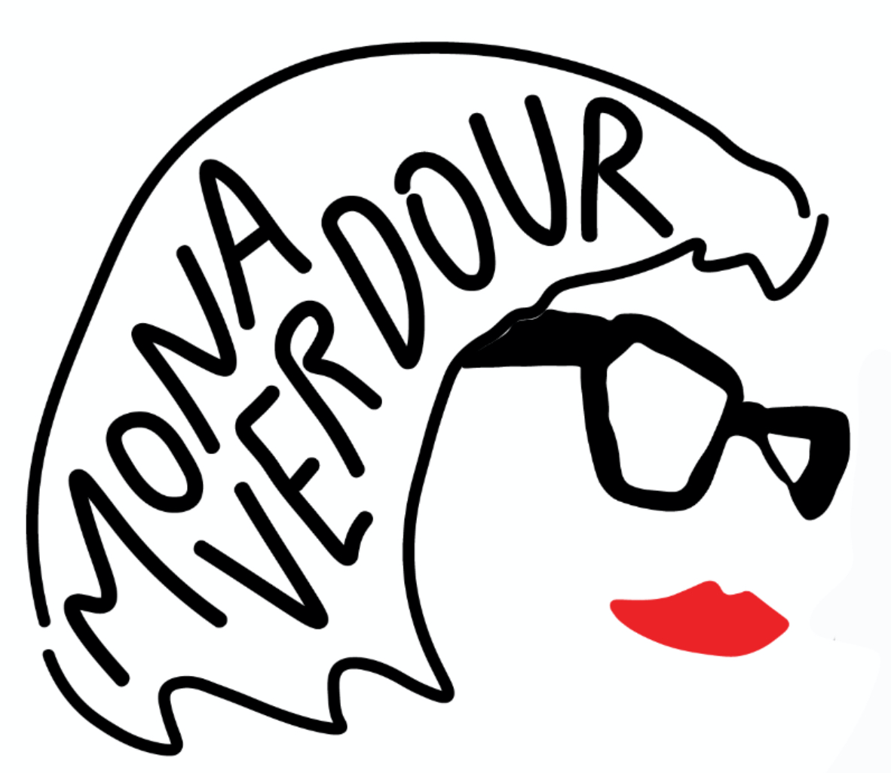

THE BIG SING

'The Big Sing' is an unforgettable interactive singing experience led by dynamic performer and choir leader Mona Verdour and her live band. Designed to break down barriers and bring people together through the joy of music, The Big Sing transforms any crowd, corporate team, community group or festival audience into a united choir. No experience is necessary, just enthusiasm and a willingness to have fun.

With Mona's infectious energy, humour and expert guidance, participants find themselves singing well known classics and uplifting anthems to create spine tingling moments of connection. Each event incorporates call and response, mash ups, tempo changes, movement, change of lyrics to well known songs, and sometimes audience members have a chance to get up on stage and 'live their rockstar dreams' and sing together with her on the microphone. Lyric sheets are supplied so guests can sing along in this 1 hour interactive show.

Whether performed in a conference hall, festival or local pub, The Big Sing delivers laughter, goosebumps and lasting memories. It is so much more than entertainment - it is a team building experience that reminds us of our collective power and the simple magic of singing together.

